**Job Aid: Preparation of Human Tissue Samples**

**Autopsy:** kidney, liver and pancreas

**Nephrectomy**

**Instructions:**

1. Contact**:** (1) Jasmine Jaber to obtain sample collection kit (9 am- 5 pm Monday-Friday), [jaberj2@chop.edu](mailto:jaberj2@chop.edu)

(2) George Yang, Research Lab Manager Phone: 202-476-2184, [cyang@childrensnational.org](mailto:cyang@childrensnational.org)

1. Receive kit and gather local supplies: wet ice/blue ice, sterile specimen containers, dry ice.
2. Patient Study ID # will be provided by Jaber. Label all specimens with this number and date of collection.
3. Complete Patient Demographic form and make 3 copies; return two copies with samples and retain one.

Use sterile technique for tissue handling.

|  |  |  |
| --- | --- | --- |
| **Phase** | **Autopsy specimen** | **Nephrectomy specimen** |
| **Dissection** | 1. Cut the fresh kidney lengthwise and then cut each half transversely.   Liver and pancreas specimens can be processed similarly. | 1. Obtain as much remnant tissue as possible (tissue not needed for clinical diagnosis) 2. For kidney, preserve the cortical area*.* |
| **Sample processing**  **(See Fig. in page 2)** | 1. Fresh kidney tissue: Place 2cm3 section of fresh kidney into 50ml sterile conical tube (provided). 2. Fixed: Cut tissue (2cm X 2cm X 0.5cm) fit into histology cassettes (5 for each tissue type) and directly fix in 10% BFA specimen container provided with kit. Store locally at room temp. 3. Snap frozen: Cut the remainder of the tissue into 0.5-1cm3 cubes and place each cube into a pre-labeled Cryo vials (provided). Snap-freeze the Cryo vials (~20 vials for each tissue type) using one of the following methods:  * Place Cryo vials in a vapor phase dewar of LN2 -- or -- * Freeze over dry ice or on the shelf of a -80oC or -20oC freezer.   Maintain the samples at storage temperature until shipment. | |
| **Packaging**  **and Shipping**  *\*Personnel shipping samples must be trained in IATA regulations* | |  |  |  | | --- | --- | --- | | **Sample type** | **Container** | **Packaging Steps** | | Fresh tissue in bag on wet ice  *SHIP SAME DAY AS COLLECTION* | Styrofoam mailing box with outer cardboard box and absorbent pads at bottom | 1. In a biohazard bag, place the 50ml conical tube with the kidney sample and wet ice/blue ice. 2. Place this bag into a second bag of wet ice/blue ice. 3. Tie off this outer plastic bag and place in Styrofoam box;); fill empty space in the container with packing material (e.g., bubble wrap, wadded paper towel or brown paper).Seal. 4. Place Styrofoam box in cardboard box. 5. Place “Patient Demographic Sheet” with the “Specimen Shipment Checklist” on top of insulated container, close the box then tape cardboard securely with packaging tape. 6. Label box with provided UN 3373 Biohazard Substance, Category B, Exempt Human Subjects. 7. Tape FedEx shipping labels on top of the carboard and ship overnight. | | Samples in 10% formalin  *SHIP FEDEX OVERNGHT SAME DAY AS COLLECTION UNLESS FRIDAY OR HOLIDAY, THEN HOLD TO NEXT BUSINESS DAY* | Styrofoam mailing box with outer cardboard box and absorbent pads at bottom. | 1. Wrap parafilm around edge of lid of the sample container to prevent leakage. 2. Place each container in sealed biohazard bag with absorbent pad. Double bag. Place bags in Styrofoam box; fill empty space in the container with packing material (e.g., bubble wrap, wadded paper towel or brown paper). Seal. 3. Place the Styrofoam box in the cardboard box. 4. Place “Patient Demographic Sheet” and “Fixed Specimen Shipment Checklist” on top of insulated container, close the box then tape cardboard securely with packaging tape. 5. Label box with provided UN 3373 Biohazard Substance, Category B, Exempt Human Subjects. 6. Tape FedEx shipping labels on top of the carboard and ship overnight. | | Snap frozen | Styrofoam mailing box with outer cardboard box and layer of dry ice on bottom | 1. In Styrofoam box, place samples in Biohazard bag and cover with more dry ice. Use 7-10 lbs of dry ice. 2. Place lid on Styrofoam container, **DO NOT SEAL.** 3. Place “Patient Demographic Sheet” with the “Frozen Specimen Shipment Checklist” on top of insulated container, close the box then tape the carboard securely with packaging tape. 4. Label box with provided UN 1845 Dry ice label, UN 3373 Biohazard Substance, Category B, Exempt Human Subjects. 5. Tape FedEx shipping labels on top of the carboard and ship overnight. | | |
|  |  | |
| **Fresh Tissue**  **Shipping information** | **Reach out to Jasmine Jaber** [**jaberj2@chop.edu**](mailto:jaberj2@chop.edu) **for shipping address** | |
| **Fixed and Frozen samples** | **Shipping Information needed from Pathology** | |

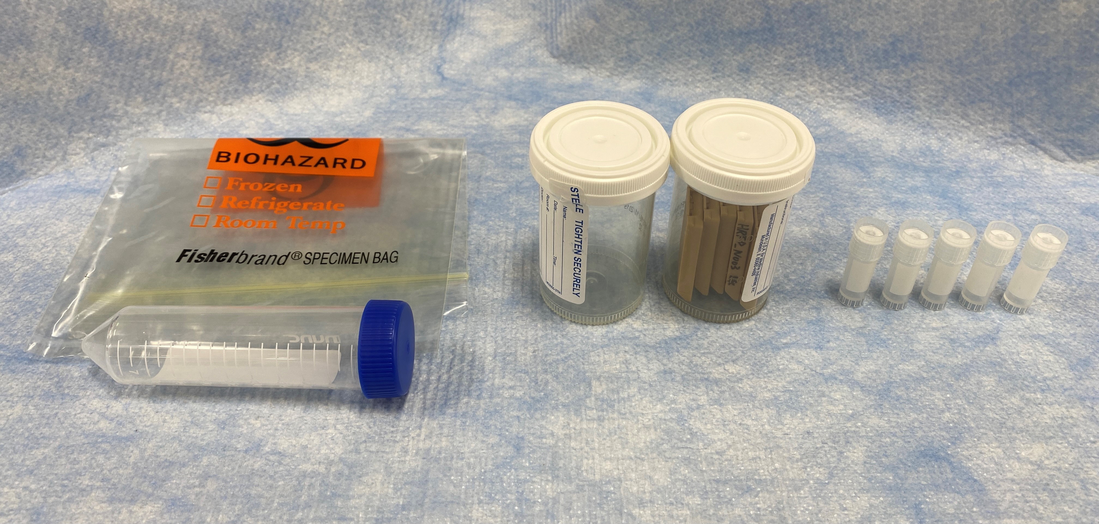

1. 50ml tube and biohazard bag for fresh kidney

2. 10% formalin containers and histology cassettes for fixed tissue

3. Cryo vials for snap frozen tissue